**Question 4.3 answers:**

**Amogha Sekhar, A53301791, CSE 250A**

1. MILLION 0.002072759168154815

MORE 0.0017088989966186725

MR. 0.0014416083492816956

MOST 0.0007879173033190295

MARKET 0.0007803712804681068

MAY 0.0007298973156289532

M. 0.0007034067394618568

MANY 0.0006967290595970209

MADE 0.0005598610827336895

MUCH 0.0005145971758110562

MAKE 0.0005144626437991272

MONTH 0.00044490959363187093

MONEY 0.00043710673693999306

MONTHS 0.0004057607781605526

MY 0.0004003183467688823

MONDAY 0.00038198530259784006

MAJOR 0.00037089252670515475

MILITARY 0.00035204581485220204

MEMBERS 0.00033606096579846475

MIGHT 0.00027358919153183117

MEETING 0.0002657374141083427

MUST 0.0002665079156312084

ME 0.00026357267173457725

MARCH 0.0002597935452176646

MAN 0.0002528834918776787

MS. 0.0002389900041002911

MINISTER 0.00023977273580605944

MAKING 0.00021170446604452378

MOVE 0.0002099555498894477

MILES 0.00020596851026319035

1. The ten most likely words to follow the word “THE”, along with their numerical bigram probabilities is as follows:

| **Word** | **Numerical Bigram Probabilities** |
| --- | --- |
| UNK | 0.615020 |
| U. | 0.013372 |
| FIRST | 0.011720 |
| COMPANY | 0.011659 |
| NEW | 0.009451 |
| UNITED | 0.008672 |
| GOVERNMENT | 0.006803 |
| NINETEEN | 0.006651 |
| SAME | 0.006287 |
| TWO | 0.006161 |

c) The unigram model yields a value of -64.50944034364878, whereas the bigram model yields a value of -40.91813213378977. Therefore, the bigram model yields a higher log-likelihood value .

1. The pair {Sixteen, Officials}, {Sold, Fire} is not observed in the training corpus. The result of this is that the probability becomes 0 and since log(0) is not defined, we get an undefined value.

e) 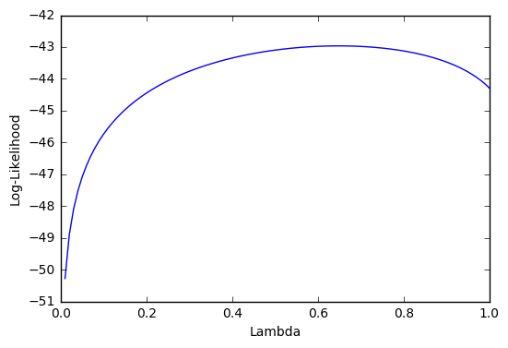

The optimal value of lambda is 0.65.